9 DENUDATION ACTIVITIES OF EXOGENIC AGENTS

Geological activity of surface water

Part of precipitation dropping out on the land surface evaporates back into the atmosphere, and part of it flows down over the surface in the form of rain and melted snow water and the part seeps into the soil.
Precipitation, flowing down on the land surface in the form of rain and snow water, composes surface effluent. Precipitation, seeping into the soil, grounds and replenished groundwater reserves, feeds underground effluent.
Rivers, draining continents, collect water of surface, as well underground effluent, and throw them in lakes, seas and oceans. Movement of river water in lakes and seas is called river effluent. River effluent goes for replenishment of water, evaporating from the surface of lakes and the World Ocean as a whole. Closed depressions on the land surface, filled with water, are called lakes. Lakes are fees by waters of surface, river, ground and underground effluent and they don’t have direct connection with World Ocean.
There is constant circulation of water on the planet on the scheme: evaporation from surface of World Ocean → precipitation on the land surface → surface and underground effluent (fig 6.3). This circulation is called large water cycle in nature, unlike small, during which water evaporating from the surface of World Ocean falls as precipitation on its surface. Water circulation, taking place within the land, is called local.
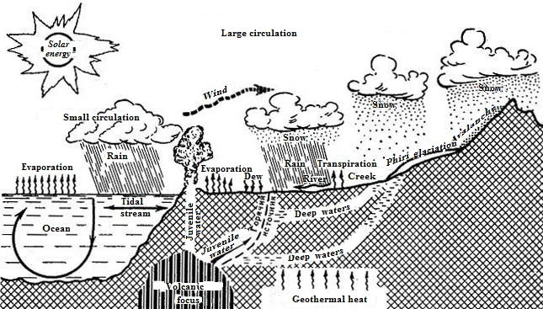
Fig. 6.3. Circulation of water in nature

All water of continents is divided into three kinds: 1) surface effluent; 2) river effluent; 3) lakes and swamps.
In activity of surface water, as well other exogenous agents, we can allocate the stages of destruction (erosion, denudation) of bedrocks, transfer (transportation) and accumulation of their destruction products.
Rain jets, covering earth surface during rainfall by the continuous veil, have minimal mass. Merging jets form streams and temporary flows, having substantial kinematic energy. Destruction activity, i.е. erosion of rain jets, leads to dissolution of some minerals, washing out and entrainment of poorly secured debris, formed under the influence of weathering processes, is called areal flushing.
Erosional activity of water during areal flushing has temporary chracter and occurs only during rain and snowmelt or mountain glaciers.
Periodic rainfall and snow melting lead to the formation of temporary streams on the slopes of the hills. These small jets – miniature water streams with depth from 2–3 to 10–25 cm – are distributed on the slopes more or less evenly, forming network of small flat-bottomed channelness troughs – деллей, or erosion furrows and potholes.
Within slope erosion activity of surface water practically stops, the accumulation of deluvium mainly occurs here. Further away from the ledge there are pediments – flattened area, within which slope surface generally does not exceed 5–7^{о}. The kinematic energy of water jets is small here and and so on pediments surface only very small and light fragments deposition occurs.
Prolonged exposure of areal flushing leads to destruction of the ledge and the parallel retreat of the slope up to the summit. Area, occupied by detrital slope and pediments, expands and pedimentation of area takes place.
Geological activity of temporary streams leads to formation of ravines and mudflows. The conditions of formation of mudflows: significant slopes of river valleys, beams, ravines or rapid snowmelt in the upper reaches, a large number of loose weathering products within the drainage basin or gully.
Geological activity of constant and temporary fluvial water streams is called fluvial process.
Temporary water streams occur during atmospheric precipitation and melting of glaciers. Fluvial shapes form genetic row, including erosional grooves, ruts, ravines, gullies, river valleys.
Temporary fluvial streams (gully and valley) deposit transported by them detrital material near the mouth and form its accumulation in the form alluvial cone (fig. 6.4). Cones reach especially large size at the foothill lowlands. The deposits of alluvial cone are called proluvium (Lat. proluo – washing out).
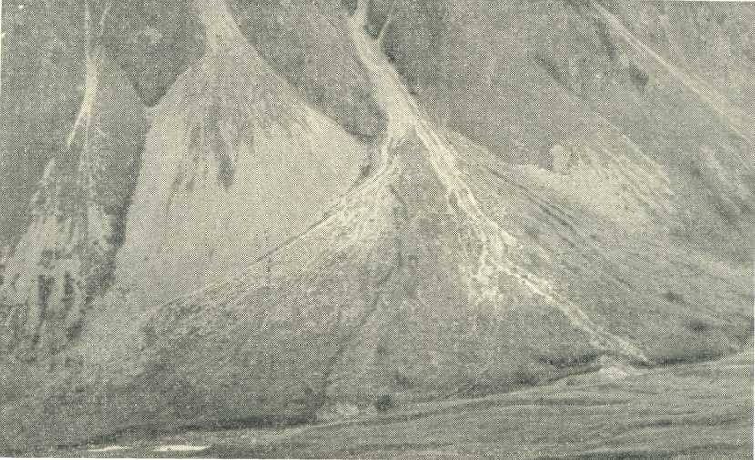

Fig. 6.4. Cones of the outflow of the mountain stream

Proluvium is characterized by mostly bad sorted material and weak rounding of debris. Thickness of proluvial deposits in the central part of alluvial cone varies from a few meters to 15-20 meters. Also the length of cones, reaching at the powerful mudslides 1-3 km and more, varies within considerable limits.
Sill – rapid, occurring suddenly the flow of water, mud and stones (sediment). Sill occurs in catchments of mountain rivers as a result of intensive rains or rapid melting of snow, and also break of debris and moraines. Sills may cause large destructions. The fight against mudflows conducted mainly by fixing the soil and vegetation, construction of special hydraulic structures.
Average speed of mudflows movement is 2–4 m/s, reaching 4–6 m/s, which makes them a great destructive effect. On their way flows are paving the deep channels, which in normal times are dry or contain small streams. Material of sills deposits in the piedmont plains. Sill streams are divided into connected and disconnected.
There are these zones in sill basin: 1) catchment area (area of feeding); 2) possible way of movement (channel of flow or transit zone); 3) area of deposits of stone material as proluvium with the formation of alluvial cone.
Горы Заилеского Алатау – classical arena for manifestations of the catastrophic floods. There are 10 large mudflow basins, 106 mudflow channels, noted 450 emissions of mudflows, or to 60% of all cases, observed in area of Kazakhstan. High mudflow activity of mountains Заилеского Алатау is caused by complex seismological and hydrometeorological conditions. At the foot of the northern slope of the picturesque гор Заилеского Алатау at an altitude of 500-1000 m above sea level on the alluvial fans of rivers Small and Big Almatinka there is Almaty – the major scientific-cultural, administrative and economic center of Kazakhstan.
There are many cities of Kazakhstan under the threat of the destructive impact of floods – Almaty, Issyk, Talgar, Kaskelen, Sarkand, Zharkent and Tekeli with a total population of over 5 million people, and also economically important objects. Therefore the problem of antimudflow protection in Kazakhstan acquired special public importance.
By the number of active mud pools, the number of cases and the magnitude of the origin of floods in Kazakhstan there can be divided into four mudflow area: 1) Zailiyskiy Alatau; 2) Dzungarian and Talasskiy Alatau; 3) Karatau, Кунгей and Kyrgyz Alatau; 4) Shu-Ile, Ketmen, Saur-Tarbagatay, Altai.
Currently regional antimudflow protection scheme of Almaty and other localities of the republic is developed. The first example of a successful fight against mudflows in our country and in the world was the construction of mudflow protection of Almaty. There were built three селезадерживающие dams: on river Small Almatinka 150-meters dam Medeu with capacity of 12,6 mln m³ and 17-meters dam Mynzhylky with capacity of 0,22 mln m³, and on river Big Almatinka – 40-meters dam with capacity of 8,2 mln m³.
Catastrophic sills in area of Almaty city were observed in 1841, 1887, 1921, 1973–77. All of them have caused great destruction and considerable material damage. Especially significant ones were catastrophic showery sills in 1921 (fig. 6.5).
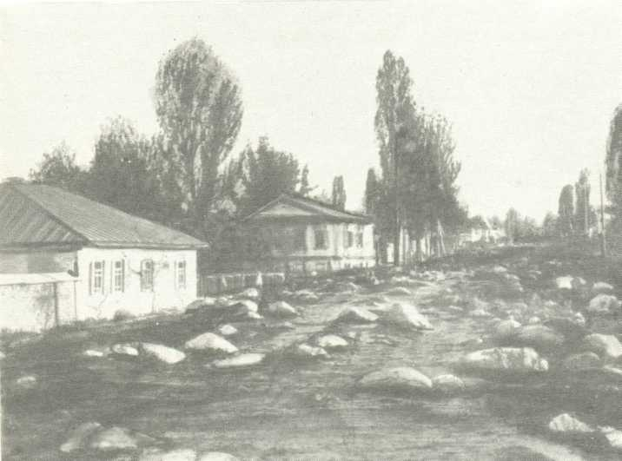
Fig. 6.5. D.а. Kunayev street after sill in 1921

Element outbroke from 8 to 9 July. Through Almaty mudflow took three directions: along the channels of the Little and Big Almatinka and Esensay (б. Весновка). Within five hours, much of the city was in ruins and flooded by debris mass. Even now many huge boulders and lumps, made by the mudflow in 1921, are as "monuments" of this devastating disaster. Preventive measures and construction of engineering structures are carried out to fight with mudflows. Guiding dams and селехранилища are effective. Dams direct the stream in desired direction and weaken its action. In areas of settlements and individual buildings, situated in the zone of proluvium deposition, they arrange branch ducts that direct the dam; the river channel is taken to the high stone coast, limiting the spreading of the mudflow. For protection of road constructions the most rational way is madflow flume in the form of concrete and stone trays, skipping sill over facilities or below them.

6.4. Geological work of rivers

Conditions of river formation: supply and terrain slope. In structure of river they distinguish: headwaters, channel, river mouth and inflows. Basin of river is river with inflows. The boundaries of the basin are watersheds. Potamology engages comprehensive study of rivers.
Rivers are continuously operating riverbed watercourses, collecting precipitation and groundwater of vast territories, called catchment basins. About 68 % of planet land is drained by rivers, which drain into the oceans and seas. About 20 % of water, annually staked by rivers, belongs to Amazon – our planet’s greatest water content river.
Erosion is a process of rocks destruction, emerging from the mechanical erosion of rocks by stream force, polishing and abrasion of channel by water streams – corrasion. Kinds of erosion: bottom and side. Stages of erosion: young, mature, decrepit. Final tage of erosion is development of the longitudinal profile of the river equilibrium. Longitudinal profile of equilibrium is curve of the river bottom elevation all the way from source to river mouth. With the erosion of the river works its longitudinal profile is continuously deepened, approaching the basis.
The intensity of the deep erosion processes usually diminishes with the approach to a level, determining the regional channel slope, – the level of the reservoir, into which river empties. Level of stream bed deepening, below which erosion activity of water flow stops is called basis of erosion. This level is the natural limit of the channel deepening. Basis of erosion is divided into absolute and local. Absolute basis of erosion is the level of World Ocean. Local basis of erosion is the level of catchment bodies of water. For example, for creeks and small rivers it can be levels of river or lake, into which they empty. There are also temporary or mobile basis of erosion in the form of various barriers to water flow (dam or outputs of solid rocks).
Changing the height of the river bottom concerning the basis of erosion throughout the channel reflects the total regional surface slope and, besides, characterizes features of area’s geological structure, through which the river flows. This curve of heights is called its longitudinal profile. Profile of equilibrium is formed not only over the entire length of the river, but also by its separate parts, so in the same river there may be several equilibrium longitudinal profiles. In river channel rapids, shoals, waterfalls equilibrium are formed. With the destruction of the waterfall scarp there is regressive erosion. The periods of youth, maturity and old age form a loop of the river erosion. Possible number of reasons: erosion base decrease, increase of source or any other section of iver, change of areas’ climate (increase of precipitation).
With the rejuvenation of river erosion cycles are repeated: first channel deepens (young, mature stage), then, the valley widens due to the erosion of shores (period of decrepitude). The former shore is raised above the level of the river – it is a terrace. Floodplain terraces are numbered from the bottom up – from younger to ancient: above the floodplain usually there are allocated the first, the second, the third and etc.
Transporting work of rivers: transportation (dragging, rolling) of clastic material, true and colloid solutions.
River sediments - alluvium is characterized by well roundness, sorted and layering. River valleys – narrow elongated, often sinuous forms of relief, at the deepest part of the valley the river flows. There are in the structure of valleys: bottom, channel, floodplain and terraces. There are accumulative, socle, erosional and terraces террасы. Structure of river mouths is largely determined by the dynamic relation between the amount of rainfall brought by the river, wave, tidal processes and tectonic raise or lower in the coastal zone. There are two types of river mouths: deltas and estuaries.
Over the lifetime the river experiences a period of youth, maturity and old age. In the period of youth a longitudinal profile of the river equilibrium has not yet developed. River flows over rough terrain, regional slope of its bed is extremely steep all over, speed of flow is high; sometimes some parts are isolated, development of which is controlled by local basis of erosion. At this stage of river development there is a strengthening process of deep (bottom) erosion, which leads to intensive deepening of the riverbed. Their valleys have shapes of gorges and canyons.
As the equilibrium profile developing the river goes into the maturity period. This period comes at the approach of the riverbed elevation to the longitudinal profile of equilibrium. During the period of maturity the river tends to deepen its channel only in the upper reaches, where deep erosion processes are still observed. In the middle and lower reaches of mature rivers deep erosion is replaced by the side. It leads to significant expand of its valley, which gets U-formed box-like shape. For this stage it is characteristic appearance of bends – meanders, leading to an increase in the coefficient of rivers winding, the formation of many sleeves, through which the water flows parallel to the main channel, and the emergence of extensive alluvial plains. At the stage of maturity the rate of flow decreases evenly from the headwaters to the mouth.
There are no clearly expressed criteria to determine the stage of maturity of the river. It is believed that the river enters the stage of old age, when the bottom of the valley reaches its width, many times greater than the width of the meandering river floodplain. At this stage in the middle and lower reaches of the river there is a strengthening process of lateral erosion, sediments are deposited and many meanders are formed. River at the stage of old age is characterized by maximal coefficient of tortuosity.
Meanders with short radius expand much faster than larger. Because of steady increase the river curvature in the undermining of the concave banks and deposition of material in convex vertices of two adjacent meander, facing in the same direction, converge closer, and between them there is only a narrow isthmus. During the period of floods there can be breakthrough of the isthmus, main mass of water rush into a new, straightening river channel, and loop will be cut off. On the cut side there is abandoned riverbed, called oxbow. Oxbows, usually, have a horseshoe shape in plan; in the future, they often turn into swamp.
During the old age of the river wide floodplain is formed in its valley, or floodplain terrace, – part of valley, poured in floods and rising above the riverbed in the low-flow period.
Periods of youth, maturity and old age make up the cycle of river erosion. Most of rivers pass all these stages of development. After the entry into the period of old age period of youth of the river can re-occur, i.e. its rejuvenation can happen. Each rejuvenation of river causes new cycle of erosion – the emergence of bottom erosion, dredging, straightening bed. In this deepening of the riverbed alluvial deposits, forming the floodplain, are above the new floodplain sediments under the new basis of erosion. Unblurred remains of ancient floodplain structures generally form the stepped ledges, hanging over the new floodplain, and are called terraces above the floodplain. Number of terraces corresponds to the number of rejuvenation stages (cycles of erosion), which river experienced during its existence (fig. 6.6).
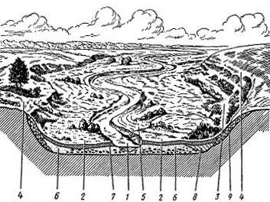
Fig. 6.6. Scheme of structure of valley of lowland river (Fig. N.P. Kostenko): 1 – canal of river; 2 – floodplain of river; 3 – overgrowing oxbows; 4 – floodplain terrace; 5 – coastal shafts; 6 – canal alluvium; 7 – floodplain alluvium; 8 – oxbow alluvium; 9 – slope formations

Structure and relief of floodplain have some characteristic features. Water of young rivers, that have significant slope, possesses big kinetic energy. This energy is spent on the bottom and lateral erosion, rolling and abrasion of debris of bedrocks and their transportation. Therefore floodplain of young rivers consists of alluvium, transported downstream. Especially quickly this movement is in the flood period, when the river draggs along the bottom the huge lumps and boulders; in the period of low water only small fragments move.
In structure of terraces above the floodplain there are a number of geomorphological elements – ledge, brow, terraced area and the rear seam. Terraces are differ from each other, particularly, by ratio of alluvial and indigenous sediments. Thus, there are terraces of these kinds: accumulative (terraces of cumulation), erosional (terraces of washout), socle (mixed).
Rivers can cut through hard rocks to form the antecedent, epigenetic valleys and valleys of interception. Antecedent (previous) is valley, formed before uplifting of structure, which the river “saws”. Wherein lifting is cut at the same rate as it grows on the river path. Antecedent valleys are characteristic to recent tectonic movements of Alatau, Karatau, Altay mountains and etc.
The destruction and displacement of watersheds take place in the process of weathering and fluvial erosion. Usually rivers, basins of which are on different sides of watersheds, destroy with various rates. This is due to the fact that the opposite slopes of watersheds, as a rule, have uneven slope, basis of river erosions, separated by a watershed may be at different levels, and watershed slopes be composed of rocks of different strength.
The totality of the processes of rock destruction and transfer of products of destruction, caused and carried out by external geological agents, is called denudation. Denudation leads to formation of characteristic forms of relief. One of such forms while monoclonal bedding of rocks is cuestas – mountains with sharply asymmetric slopes. Gentle slope corresponds to the angle of monoclinal layers fall, and sharply is formed in area of their denudational cutting. Cuesta relief is typical for inhomogeneous in composition (and strength) of rocks exposed to intense denudation. Erosional impact of exogenous factors is particularly evident in the mountain systems, where processes of denudation pass with high speed. Entire mountain countries are transformed into slightly hilly plain under the influence of denudation. Subsequent uplift of primary denudation surface leads to a deepening of the existing river network and the creation of a system of ravines – canyons. Thus, ascending endogenous movements are fully compensated denudation processes. Formed during this, plateau, folded by intensively dislocated rocks and rugged by deep canyons, is called the marginal plain, or peneplain.
Classical example of peneplain is south-western part of USA’s area, experiencing intense uplift. It is widely known deeply incised valleys (Grand Canyon) r. Colorado. The length of the canyon is 300 km and a width of up to 18 km. Almost steep canyon walls often have a height of 2-3 km, and composing its horizontal layers rocks form a system of steep terraces. One of such natural wonders is also known in Kazakhstan. It is Charyn Canyon, which is called the Palace of the rocks.
In alluvial deposits ther are placer deposits, formed by the destruction of bedrocks or primary deposits. Rocks, containing ore and non-metallic minerals in primary laying, are often eroded in the process of erosion. Part of destruction products are carried away by the waters of the rivers and scattered, and part under favorable conditions is deposited in alluvial terraced sediments. As a rule, high density minerals are delayed in alluvium. Sometimes accumulations, presenting in the alluvial sediments, of valuable minerals can form a sufficiently high concentration, cost-effective to develop. Alluvial deposits of gold, platinum, diamonds, tungsten, scheelite, silver, magnetite, hematite, chromite, garnet, zircon, etc. are formed in this way.

6.5. Geological activity of lakes and swamps

Lake is isolated, sometimes weakly running body of water. Depending on water regime lakes are divided into flow and stagnant. There are significant differences in the depth of the lake, the water salinity and etc.
The main classification criterion of the lakes is the origin of lake basin. On this basis there are exogenous lakes, the origin of which is associated with the surface factors, and endogenous, appearance of which is due to the surface manifestation of underlying factors.
Exogenous lakes are divided into basins and dams. Basin lakes depending on origin of basins can be erosional and disastrous (karstic). Among erosional lakes there are glacial, river and eolian. Glacial lakes fill trough valleys, related to geological glacier activity, river lakes are formed in closed-off areas of channel – oxbows, eolian lakes are located in recesses of aeolian origin, usually in blowing hollows. Disastrous (karstic) lakes appear on the site of the failure of the Earth's surface over the karstic or other voids. Dams are called lakes, in which as one of the walls of the recess serves a dam. Depending on origin of dam there are lakes glacial, avalanche, landslide, moraine and etc.
Endogenous lakes are tectonic and volcanic lakes. Tectonic lakes are usually formed as a result of lowering crustal blocks (for example, Baikal, Rizza and etc.), volcanic lakes are often related to the craters of extinct volcanoes.
Another feature of the classification of lakes is their water regime. On this basis the lake is divided into flow and stagnant. Flow lakes are related to both flowing into them, and the consequences of them rivers. An example of a flow lake is Baikal, in which flow many rivers (Selenga, Barguzin and etc.) and from which flows Angara. Stagnant lakes are only flowed by rivers. Example of such lakes can be Caspian and Aral seas.
An important role is played by the chemical composition and mineralization of the lake waters. By mineralization of water lakes are divided into fresh, brackish and salty. Mineralization of fresh lakes does not exceed 1 ^{о}/_{оо}; example of such lakes is Onega with mineralization up to 30 mg/l. Brackish category includes lake with a salinity of 1 to 24,7 ^{о}/_{оо,} for example, Caspian sea with mineralization about 13 ^{о}/_{оо}. Mineralization of salty lakes’ water exceeds 24 ‰; for example lake of Elton with mineralization to 28 ‰.
By the composition of salt lakes are divided into soda, sulphate and salt.
The destructive work of the lakes is coastal abrasion. Organical world of lakes: protozoa, molluscs, fish, algae. Sediments of lakes: terrigenous, organogenous, chemogenic.
Swamps are excessively wet areas of land surface, within which marsh vegetation develops followed by the accumulation of peat. Lake baths are short-lived, filled by sediments, they become overgrown with vegetation. Swamps are feed by atmospheric and groundwater.
Geological work of swamps is the formation of sedimentary rockspeat, lignite, brown and hard coal, sapropel mud. Swamps are formed mainly in the lowlands, in the place of continental and coastal-marine lakes. Their development can occur at higher, but wetland areas (places of groundwater outcrop and etc.). Area of all swamps in the world is 175 mln km², 72,6 % of them are located on the CIS territory. there are lowland, upland and transitional swamps.
Lowland swamps originate in the river valleys, on the site of oxbows, in river deltas, with glacial shallowing, coastal-marine and other types of lakes. The first sign of eutrophication of lakes is the appearance of marsh plants in the the coastal area: sedges, reeds, rushes, mosses and etc. Over time marsh plants gain shallow bottom areas, gradually spreading to the center of the lake. In central part of lakes at this time the algae are intensively developed. As wetlands development mosses, shrubs, birch, sedge come to replace the cane and reed vegetation.
Dying plants accumulate at the bottom, become compressed, partially decompose and turn into brown (sometimes black) plant mass, called peat. Iron and manganese ore are formed along with peat in some swamps. Depending on surroundings, in which iron precipitation, as the sediment can fall carbonate (siderite) or hydrooxidic (limonite) iron compounds. Limonite is also formed by the oxidation of siderite. Thickness of swamp iron ore is measured by units and tens of meters. On the territory of Belarus and Karelia several tens of ore-bearing lakes are revealed.
Lowland bogs are most prevalent in Karelia, Kola Peninsula, in Belarus, less – in central areas of European part of the CIS, in the West Siberian Plain, Far East and some other regions.
Lowland swamps are located at different stages of development. Some of them are already turned into grasslands, others are used for the development of peat, others are in the initial or final stage of development.
Coastal sea marshes are known in Kamchatka, on the coast of the Sea of Okhotsk, on the coast of the Black Sea in a number of places of the tropical and subtropical zones. In these swamps, as well as in continental, peat and in some cases iron ore accumulate. The most important are peat deposits of littoral swamps of tropical and subtropical zones, consisting not of small plants and mosses, and of tree trunks, their branches and roots (in place of mangroves).
Upland swamps are less spread. They are met on the watershed areas of the tundra zone, in places of emergence of groundwater to the surface and abundant rainfall. Vegetation of upland swamps is represented mainly by green (hypnum) and white (sphagnum) moss. There are occasionally bushes and swamp dwarf pine among mosses. Intensive development of mosses in central part of swamps promotes the formation of the convex shape of the surface. Peat of upland swamps has a higher calorific value and low ash content.
Transitional swamps occupy an intermediate position between the upland and lowland bogs.
Minerals of lake and marsh sediments. Process of lake and marsh sediments formation occurs continuously over many millions of years. In place of some lakes and wetlands come other. It is promoted mainly by tectonic movements of the crust, causing periodically update the land relief.
The sediments of ancient lakes a long time ago passed into the fossil state. They can be found at depths of tens and hundreds of meters in section of the Earth's crust. Liquid oozes of pre-existing wetlands and lakes have changed their original appearance. Under the pressure of the overlying strata they are compacted and turned into sedimentary rocks. Lime sludge, for example, became limestones, diatom and dolomite – diatomite and dolomites, clayey and clay-calcareous – clay and marl.
Significant changes are subjected to peat deposits turning into coal. Conversion of peat into coal was contributed by further decomposing of plants due to insufficient or complete absence of free oxygen anaerobic bacteria, yeasts and other microorganisms. Complete decomposition of plant matter and its carbonization in conditions of high temperature and pressure at first leads to the conversion of peat in dark brown or black with a matte luster rock – brown coal. Exterior changes of matter were caused by the restructuring of the structure and increasing carbon content (from 60 to 75 %). Brown coals have various ages, measured by tens to hundreds of millions of years. In Maykobe basin and Karazhyra deposit the time of their formation is referred to the Jurassic, in the Moscow basin - to the Carboniferous.
In further coalification occurring at higher temperatures of bowels (300–325°), brown coal is converted into black coal with higher carbon content – up to 95%, which has glassy luster and higher hardness. The final point of carbonification is the formation of anthracite – combustible rock with conchoidal fracture, matallic glassy luster and a carbon content of 93 to 98%. Black coals and anthracites are known among coal deposits of Donbass, Kuzneckiy, Kanskiy and other coal basins.
Sapropelic silts, consisting of remnants of animal origin and lower plants (phytoplankton, algae), are eventually converted into sapropel coals and oil shale.
Besides combustible mineral resources deposits of sand, clay, limestone, dolomite, marl, diatomite, salt, iron and manganese ores are associated with lake-marsh deposits. It has long been known and developed iron and manganese ores of Lipesk, Tula, Nikopole and Urals. Sapropelic and peat silts are used as therapeutic mud. In lakes of Kazakhstan and Western Siberia they are developing deposits of soda and mirabilite. Salts of boron are produced in lakes of USA (Searles lake), Chile, Argentina and some other countries.
The most widespread mineral resources of lake-marsh deposits are peat. It is used as fuel, fertilizers in agriculture and the chemical industry.

Control questions
- What is denudation?
- What is proluvium and how it differs from deluvium, eluvium and colluvium?
- What is geological work of surface flowing waters?
- What is sill?
- What is the name of destructive work of rivers and what types does it have?
- What is erosion basis, what kinds does it have?
- Name morphological elements of river valleys.
- What are antecedent valleys and how are they formed?
- What is alluvium?
- What are the placers?
What is geological activity of lakes and swamps?

